Requirements

Install Python libraries (ONE by ONE)
pip install torch
pip install sounddevice scipy numpy
winget install Gyan.FFmpeg
pip install -U openai-whisper
pip install python-docx
pip install reportlab

Otherwise you can go with option 2nd

Create requirements.txt for your Meeting / MoM Generator project

requirements.txt
torch
numpy
sounddevice
scipy
openai-whisper
python-docx
reportlab

How to Run a Project ?

Run project run as per the sequence

Step 1) Records audio from microphone
1st run this command python record_meeting.py
Press Enter button ( Then start recording )
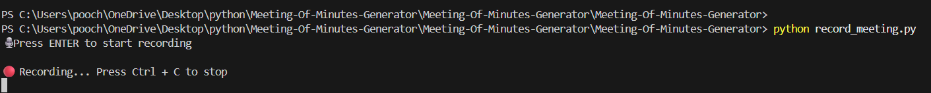Press Ctrl + C (for stopping recording)
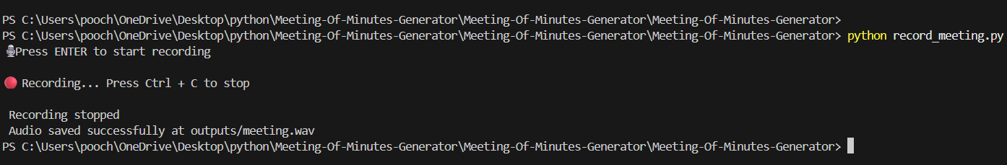
Audio saved at outputs/meeting.wav

Step 2) Converts audio to text

2nd run this command python transcribe.py

Full meeting transcription saved at outputs/meeting_transcript.txt

Step 3) Logic to extract action items

3rd run this command python action_items.py

Extracted action items saved at outputs/action_items.txt

Step 4) Main script to generate MoM

4rth run this command python mom_generator.py

Generate Minutes of Meeting (Text) saved at outputs/MoM.txt

Step 5) Export MoM to Word

5th run this command python export_word.py
Export MoM to word saved at outputs/MoM.docx

Step 6) Export MoM to PDF

6th run this command python export_pdf.py

Export MoM to PDF saved at outputs/MoM.pdf

